
Rosary Memorial Garden Order Form

SPONSOR NAME: _________________________________________________________________________________________
ADDRESS: _______________________________________________ CITY/STATE/ZIP: _________________________________
EMAIL: ____________________________________________________ PHONE NUMBER: ______________________________
LOCATION: _____________________________________________ SPACE: _________________________________________
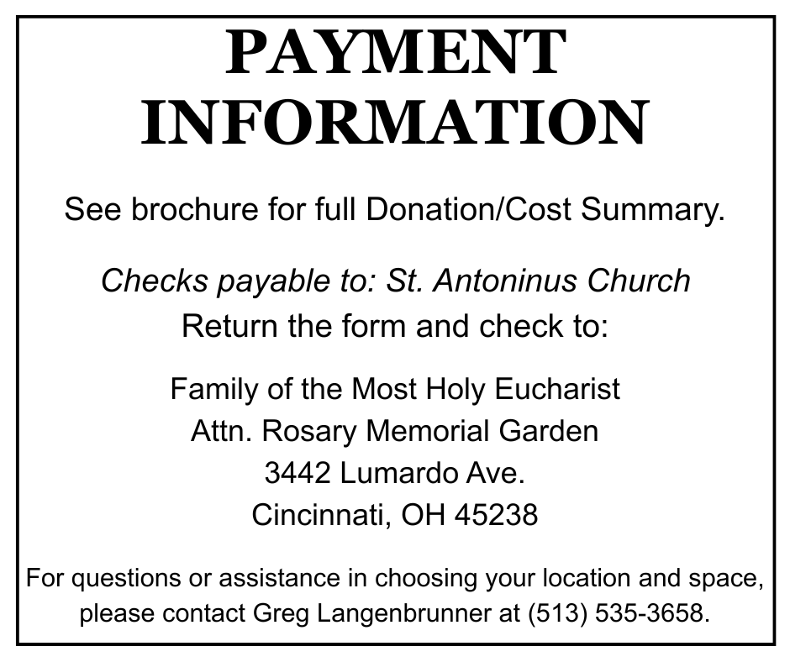
INSCRIPTION: Please check and complete your desired memorial inscription in the appropriate box below. Stone Mason will balance inscription on markers and benches.

SQUARE MARKER [ ] Donation: $__________
NOTE: ELEVEN (11) CHARACTERS PER LINE INCLUDING SPACES / FIVE (5) LINE

RECTANGULAR MARKER [ ] Donation: $__________
NOTE: THIRTY-TWO (32) CHARACTERS PER LINE INCLUDING SPACES / FIVE (5) LINES

BENCH [ ] Donation: $__________
NOTE: FIFTY (50) CHARACTERS PER LINE INCLUDING SPACES / ONE (1) LINE

